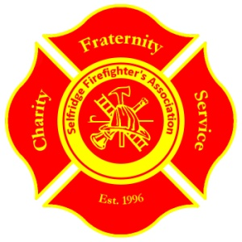
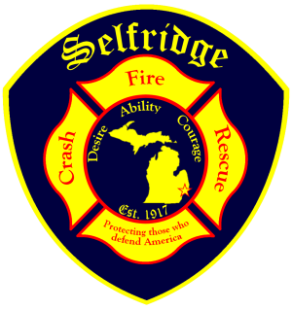
Selfridge Firefighter’s Association
28000 George Ave. Bldg. 859
Selfridge ANGB, MI 48045
586 239 4103

The 28th Annual Golf Outing Fundraiser
Hosted by the
Selfridge Firefighter’s Association

Friday, July 22nd, 2016

Event is located on Selfridge Air National Guard Base
at the Selfridge ANGB Golf Course.

Registration is limited to the first 36 foursomes

All Proceeds Benefit the
“Wigs 4 Kids” Charity

SHOW YOUR SUPPORT BY:
- Sponsor a kid. $800 buys a kids wig, counseling, golf pin flag with their pic/your logo, you keep
- Making a separate monetary TAX deductible donation
- Being a Diamond, Gold, or Silver Sponsor
- Getting a team or two together and golfing in the outing
- Donating raffle items
- Promoting your business with golf favors for 150 players

7:30 a.m. ~ Registration Begins
9:00 a.m. ~ Shotgun Start
3:30 p.m. ~ Dinner Starts
4:00 p.m. ~ Awards Presentation and Raffles

“It’s for the kids. Let’s give the kids a sunny smile.”
Through your donations, last year we raised $20,000 for the kids!!!

(over)
Please check your sponsorship type below and return form with check to address provided.

Sponsor a kid. Buys a wig, provides counseling, provides golf pin flag w/ kids pic and your message/logo………$800

Any Monetary Tax deductible Donation to “Wigs 4 Kids”, fill in blank ………………………………………$........

Diamond Sponsor (Includes; choice of starting tee location, one team of four, hole sponsorship and four Selfridge golf outing polo shirts embroidered with logo, please state sizes)…………………..……….……………………….…..$1000.00

Gold Sponsor (Includes; one team of four, hole sponsorship and four Selfridge golf outing polo
Shirts, embroidered with logo, please state sizes)…………………………………….…………………...……....$800.00

Silver Sponsor (Includes; one team of four, one hole sponsorship)…………………………………………..…. $650.00

Hole Sponsor (Includes; a sign and place for your business brochures. You are welcome to have a Representative at your sponsored hole.) Plus be our guest for dinner…………………………………………...................................... $250.00

Driving Range Sponsor (Includes; a sign with your company name and logo placed at the driving range)…..... $150.00

Cart Sponsor (Have your company name and logo placed on a golf cart during the golf outing)………………... $50.00

Team Registration fee (Includes; four person team, lunch, dinner, drinks, gift)……………………………….…$400.00

Dinner Ticket only……………….…………………………………………………………………………………$40.00

TOTAL…………………………………………………………………………...................$---------

We look forward to recognizing every
Sponsor at the Golf Outing banquet.

Company Name ___________________________________________________________________
Contact Person _____________________________________________________________________
Email Address ____________________________________________________________________
City______________________ State___________________________ Zip ___________________
Phone ____________________________ Fax____________________________________________
Diamond and Gold Sponsors- Please List Players Names and Shirt Sizes..………………………….…
……………………………………………………………………………………………………………
…………………………………………………………………………………………………………… ……………………………………………………………………………………………………………
Forward registration and payment to:
Selfridge Firefighter’s Association
Selfridge Fire Department
28000 George Ave, Bldg. 859
Selfridge ANG Base, MI 48045
(Tax ID number: 20-0374667)

For information call Bob Howard: work- (586) 239-4103 cell- 248-444-5353 FAX (586) 239-5507
Or email robert.howard.15@us.af.mil

